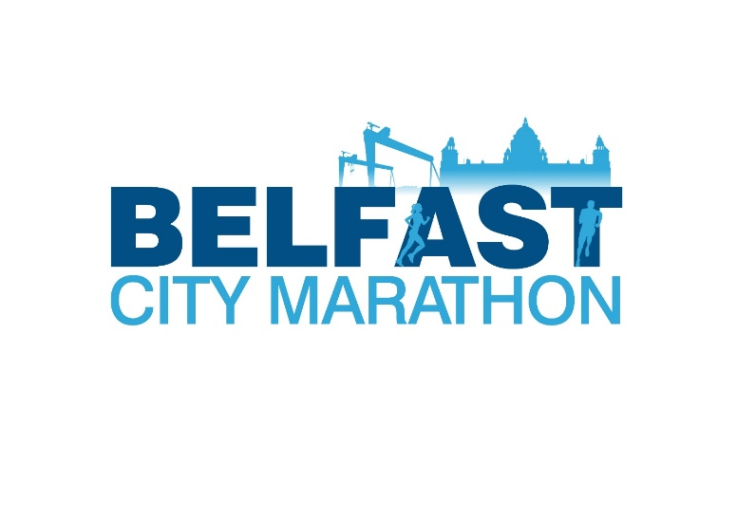
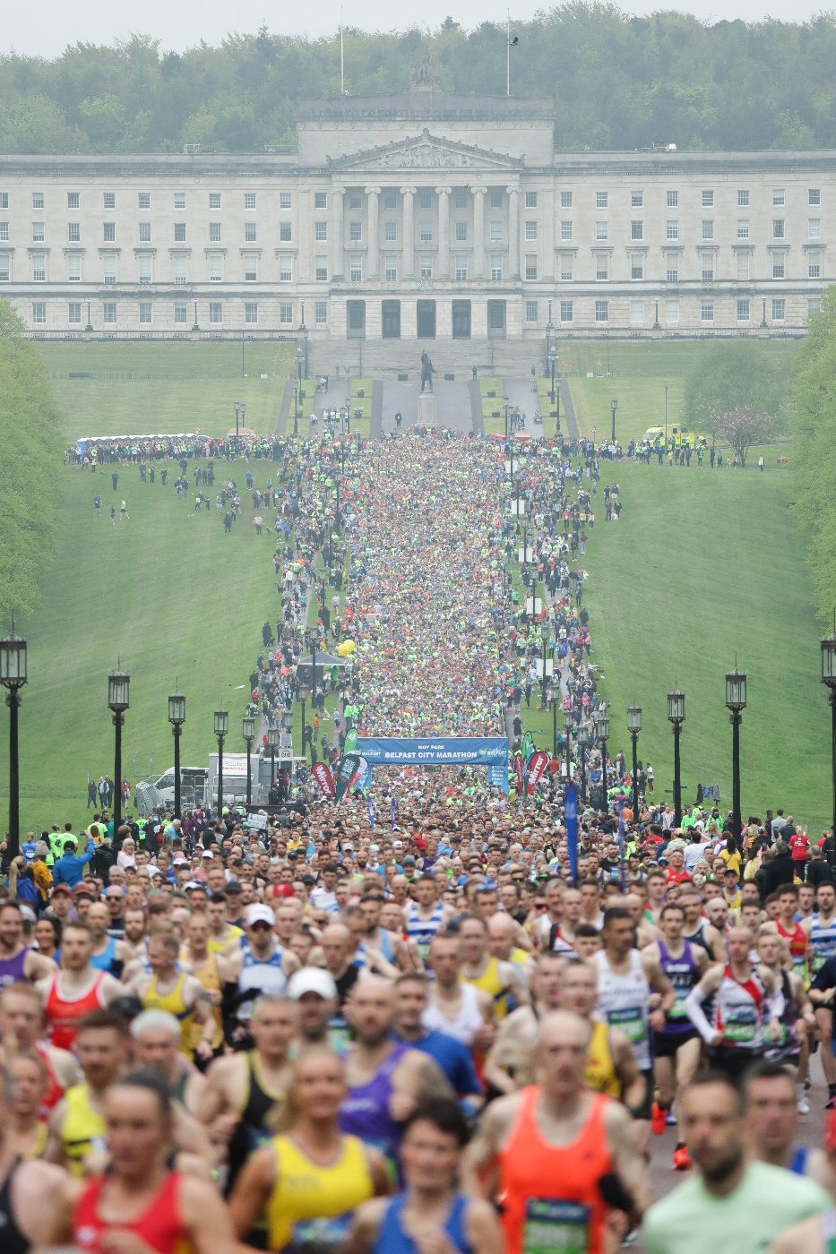
Welcome to Belfast City Marathon
Dear Applicant,
Belfast City Marathon is seeking to recruit for a new and exciting role for an Operations Manager to manage the Belfast City Marathon and associated events.
Belfast City Marathon is honoured to offer two major sporting events to the athletics calendar annually in Northern Ireland: Moy Park Belfast City Marathon (May) and the Moy Park Belfast City Half Marathon (September), alongside the Moy Park Belfast City Women’s 10k (June) and the Moy Park Belfast City 5k (November).
As an organisation we are proud of all our participants as they take on their personal challenge whether it is the 26.2-mile run, half marathon, 8-mile walk, 10k, leg of the relay team or a 5k. We are grateful for the support of the community who act as volunteers over Race Weekend as well as supporting the athletes as they run, walk, or jog past their front doors.
In 2025 we look forward to celebrating our 43rd year and appeal to all to get involved and be part of running history in Northern Ireland with the Belfast City Marathon.
This is a unique opportunity for an experienced Operations Manager to work with Belfast City Marathon to deliver successful events.
We are seeking a self-starter with excellent initiative and communication skills and who has a passion for events and a desire for continuous improvement.
The successful candidate will have excellent organisational, management, and relationship and negotiation skills and be able to deliver successful events.
The closing date for application is Friday 24th January 2025 at 12noon. Interviews are scheduled for Friday 31st January 2025.
Late applications will not be considered.

Yours sincerely

Mr. John Allen, Chair of Belfast City Marathon.
Belfast City Marathon

Who are we?
Belfast City Marathon Ltd was set up in 1982 with 3,021 people taking part in a marathon only event by Athletics NI (formerly Northern Ireland Athletics Federation), Belfast City Council and Guinness. In 2025 the Company will celebrate its 43rd year (cancelled event in 2020 due to Covid-19) with title sponsor “Moy Park” and look forward to local, national, and international participants lining the Prince of Wales Avenue at Stormont Estate for the start.
In 1989 the organisers introduced the Team Relay event for teams of 2-5 runners to follow the marathon course. In 1997 the Fun Run and Walk Events were added to the Company’s portfolio to allow for increased participation and physical abilities. In 2013 a second date was added to the running calendar with a half marathon taking place on the 3rd Sunday in September annually. 2023 saw the introduction of our first women’s only event, the 10k and more recently in November 2024 a family festive 5k was staged.
Since its inception in 1982 over 800,000 people have participated in one of the events whilst raising millions of pounds for local charities.
What do we do?
The main purpose of the company is to plan and deliver the annual Belfast City Marathon (May), Belfast City Half Marathon (September), Belfast City Women’s 10k (June) and the Belfast City 5k (November) encouraging people to stay physically active and raise money for local charities.
Our core work values.
- To increase the physical activity of people of all ages and genders locally, nationally, and internationally.
- To engage with the public/private/charity sector by offering opportunities including volunteer duties.

JOB DESCRIPTION

Job Title | Operations Manager
Location | Marathon Office, Sir Thomas and Lady Dixon Park, Upper Malone Road, Belfast BT17 9LA  *Part time Hybrid options available.
Hours | 37 hours per week
Salary | Up to £42,000 per annum
Report To | Chief Executive
Job Purpose
The Operations Manager is responsible for the delivery of all events associated with the Belfast City Marathon including planning, organising, recruiting, training and deployment of volunteers, marketing and administering and undertaking any research necessary for events under the direction of the Chief Executive.
Key Accountabilities and Responsibilities
Event Management
- To plan, prepare, organise, and manage all aspects of events associated with the Belfast City Marathon including undertaking any research necessary for events under the direction of the Chief Executive.

- To establish and maintain good working relationships with council departments and sections, civic dignitaries, members, stakeholders, statutory agencies, voluntary organisations, and key external partners to ensure a corporate approach to all major events when required.

- To ensure all event information is updated accurately and uploaded to the website and communicated through social media channels in adequate time.

- To ensure the necessary high standards of service delivery at events etc. through the management of volunteers and others working for the company and contracted staff to ensure that all events are delivered to the highest standards, taking into account all relevant company policies.

- To assist the Chief Executive with the strategic marketing plan.

- To deliver the operational marketing plan.

- To manage and promote all events, including advertising, branding, the production of printed materials and distribution of materials.

- To prepare reports for the Chief Executive on the evaluation and economic impact of each event.

- To manage and represent Belfast City Marathon at marketing meetings for all events and sponsors.

- Liaison with various suppliers for the events to ensure the promotions are properly organised.

- In conjunction with the Chief Executive, to attract sponsorship and liaise with national and international agencies to source funding and grants ensuring successful applications comply with conditions of the funding offer, gather evidence and compile/process funding claims as required. To manage the procuring media sponsorships and value in kind related to events.

Health and Safety
- To manage the management and implementation of all health and safety issues associated with events from planning through to post evaluation as directed by the Chief Executive.

- To ensure that all legal requirements are met in the planning, delivery, and implementation of events on behalf of Belfast City Marathon, including application for relevant licences, contracts, insurance documentation, risk assessments, method statements and child protection policies prior to events.

- To write event management plans in accordance with H&S guidance and legal obligations for events as required
.
Team Management

- To provide induction, support, advice, direction, supervision and appraisal to the Senior Events Officer, Admin and Events Assistant and Marketing and Events Assistant.

- To support and manage the above whilst providing regular supervision.

- To supervise the above to ensure that relevant events administration is conducted satisfactorily.

- To adopt and sustain a flexible and adaptable approach to the work of the team.

Volunteer Management
- To recruit, train and deploy volunteers for all Belfast City Marathon events working with the Senior Events Officer.

- To participate as directed in Belfast City Marathon’s recruitment and selection interview programme as required by the Chief Executive.

Professional Development
- With the Chief Executive, be responsible for maintaining your own personal and professional development.

- To use all relevant learning opportunities to improve personal skills so as to improve the effectiveness and efficiency of service delivery.

- To have an annual appraisal and regular support, supervision, and guidance

Other duties
- To assist in the drawing up and assess quotations and assist with the management of the tender process as required.

- To undertake the duties in such a way as to enhance and protect the reputation and public profile of Belfast City Marathon.

- To undertake such other relevant duties as may from time to time be required.

General
The key responsibilities above give a broad outline of the functions of the post. However, these duties must be approached in a flexible manner. The post holder will be expected to adapt to changing circumstances and undertake other duties appropriate to the grade of the post as allocated by your line manager as part of working in a small team to deliver the Belfast City Marathon from time to time.
- To adhere to existing work practices, procedures, undertake relevant training and development activities and to respond positively to new and alternative systems.

- To demonstrate their commitment to Belfast City Marathon by their regular attendance and the efficient completion of all tasks allocated to them.

- It will be necessary to work with information technology and associated systems in accordance with Belfast City Marathon Policies and Procedures.

- To co-operate with Belfast City Marathon in complying with relevant health and safety legislation, policies, and procedures, in the performance of the duties of the post.

- To perform duties and responsibilities of the post in compliance with Belfast City Marathon’s equal opportunities policies.

- To maintain confidentiality and observe data protection and associated guidelines where appropriate.

Person Specification

Essential Criteria
Knowledge and Experience
- 4 years’ experience of event management with the ability to organise events of assorted sizes from start to end.

- A strong knowledge of the events sector and what is required to ensure the financial sustainability of events.

- 3 years’ experience of staff management.

- Knowledge of Health and Safety legislation in relation to events.

- Experience in the design and implementation of event specific risk assessments.

- 2 years’ marketing experience, including digital marketing.

Skills
- Excellent Communication skills both written and verbal with the ability to deal with a wide range of clients at all levels.

- Excellent Time Management skills.

- Excellent relationship building skills.

- Effective team building skills.

- Proficient in the use of Microsoft word, Excel, and PowerPoint.

- The ability to manage, motivate and lead a team of staff.

- The ability to manage under pressure and work to targets and tight deadlines.

- To be self-motivated and have the ability to work: independently or as part of a team.

- The ability to work on your own initiative and to use initiative to solve problems and make decisions.

Circumstances
- Able to work evenings and/or weekends when required.

- Have access to a mode of transport that allows you to fulfil all requirements of the post.

Desirable Criteria

- Third level qualification in a relevant discipline – Events Management, Marketing, Business Management, Project Management.

- Professional marketing or digital qualification.

- Experience of managing volunteers.

- Experience in sports management and/or delivery of sporting events.

NB: These criteria may be enhanced to aid shortlisting. For each of the essential criteria, candidates are expected to provide evidence of how they meet the specific requirements. The panel cannot draw inferences from the material supplied so clear evidence must be stated if the candidate is to be deemed to have met the essential criteria.

Conditions of Service
Position: Operations Manager
Location: Marathon Office, Sir Thomas and Lady Dixon Park, Upper Malone Road, Belfast, BT17 9LA.*
*Part time hybrid working available.
Reports to: Chief Executive.
Salary: up to £42,000 per annum
Hours: 37 hours per week.
Leave: 25 days leave per year (30 days leave after 5 years’ service).
Customary holidays 11 days per year - The Belfast City Marathon Office closes across the whole festive period – this normally necessitates 3 days of annual leave to be taken by all staff.
Probationary Period: 6 months

- Pensions
- All employees will pay a minimum of 5% of their salary monthly and Belfast City Marathon Ltd will also contribute 5%.

- Employee Assistance Programme
  - All employees will be entitled to membership of the organisation’s employee assistance programme. Providing around-the-clock access to high quality and professional support on a wide range of real issues.

- Work Uniform
  - All employees will be required to wear a suitable branded uniform at all events, and this will be provided by Belfast City Marathon.
The Recruitment Process
Please read the following carefully before completing your application form.
Application form (available as a separate document).
The application form: All sections must be completed, if it is not applicable state so. Applicants, please ensure that you first read the essential criteria on the person specification and the duties on the job description to see if you are suitable for the post. If you feel you are, you must write specific examples on the application form demonstrating how you meet every essential criteria – as this is what the short-listing will be based on.
Personal details: Make sure that your contact details are clearly displayed. If you move house, between sending in your form and being interviewed, please let us know as soon as possible. All personal details will be removed prior to the selection process.
Shortlisting: Applicants will be shortlisted against the criteria in person specification.
The interview: All shortlisted applicants will be contacted by email to offer an interview. The interview date is Friday 31st January 2025 in person at the Marathon Office.
You will be informed of the time and contact for the interview.
Applicants will be asked questions relating to the job description, person specification and application, and the panel will take notes during the course of the interview. This is part of the procedure to ensure that all applicants are treated equally, and to help us to make the right decision.
In preparation for the interview, take the opportunity to read through the job description, application form, and any other literature sent as part of the information pack, and be prepared to talk about your experience, giving examples that illustrate your ability to do particular parts of the job. If you have any special requirements that would allow you to participate more fully in the interview, let the Chief Executive know when you are invited to the interview.
Applications will only be accepted on the official application form. Attached CV’s will not be considered, either in lieu of the application form or in conjunction with it.
How to apply:
Applications can be downloaded from https://belfastcitymarathon.com/event-info/jobs
It is the responsibility of the applicant to ensure an email or signed hard copy of the complete forms, together with an Equal Opportunities monitoring Form, (please put it in a separate email marked Monitoring Officer is returned by 12 noon on Friday 24th January 2025. Applications received after this time and date will not be accepted.
Please send your completed application from to: claire.oneill@belfastcitymarathon.org by 12 noon on Friday 24th January 2025.
Interview invites will be issued after this date, with interviews occurring on Friday 31st January 2025.
We look forward to hearing from you and wish you all the best in your application and the process ahead.
Privacy notice for Applicants
1.Introduction
Belfast City Marathon is a “data controller.” This means that we are required under data protection legislation to notify you of how we will collect and process your personal data relating to job applicants as part of our recruitment process. This notice will explain how we collect your personal data, its use, storage, transfer, and security. We will also explain what rights you have in relation to how we process your personal data. It is important that you read this notice, together with any other privacy notice we may provide during your employment. so that you are aware of how and why we are processing your personal data. We may update this notice at any time.
2. Data Controller Obligations
We are required by law to ensure that when processing any of your personal data that it is:
- Used lawfully, fairly and in a transparent way.
- Collected only for valid purposes that we have clearly explained to you and not used in any way that is incompatible with those purposes.
- Relevant to the purposes we have told you about and limited only to those purposes.
- Accurate and kept up to date.
- Kept in a form which permits you to be identified for only as long as necessary for the purposes we have told you about.
- Kept securely.

3. Information we collect about you
- Your name, salutation, addresses, contact numbers, and personal email addresses.
- Date of birth.
- Gender and religious background.
- Identification documentation -Copy of driving licence, passport etc.
- Documentation relating to your right to work in the UK.
- Copies of the right to work documentation.
- References and other information included in or cover letter or as part of the application process.
- Records of your previous employment (including job titles, work history, working hours, training records and professional memberships and salary details)
- Information from interviews you may have.
4. Collection of Data
We may collect this information in a variety of ways. For example, data might be contained in application forms (including when these are sent to us as part of speculative applications or queries), obtained from your passport or other identity documents, or collected through interviews or other methods of assessment or an employment agency. We may also collect personal data about you from third parties, such as references supplied by former employers. We will seek information from third parties only once a job offer has been made to you.
Personal Data is kept in personnel files or within Belfast City Marathon HR and IT systems.
5. Usage of your personal data
We will only use your personal information when the law allows us to. Most commonly, we will use your personal information in the following circumstances:
- To process your application and to help us decide whether to make an offer of employment to you.
- Where we need to comply with a legal obligation.
- Where it is necessary for our legitimate interests (or those of a third party) and your interests and fundamental rights do not override those interests.
6. Purpose for using your personal data
We may process your data for the following purposes:
- Making a decision about your recruitment or appointment.
- AccessNI checks.
- Determining the terms on which you work for us. Checking you are legally entitled to work in the UK.
- To prevent and detect fraud.
- Equality and diversity monitoring.
How we process “special categories” of more sensitive personal information
We may also collect, store, and use the following “special categories” of more sensitive personal information:
- Information about your race or ethnicity, religious beliefs, sexual orientation, and political opinions.
- Trade union membership (only where you have mentioned this in your application e.g., where you list being a union representative in “positions of responsibility”).
- Information about your health, including any medical condition, health and sickness including pre-employment screening.
- Information about criminal convictions and offences.
We only collect criminal conviction data where it is appropriate given the nature and where the law permits us. This data will usually be collected at the recruitment stage; however, it may be also collected during employment should you be successful in obtaining employment.
These “special categories” of particularly sensitive personal information require higher levels of protection. We need to have further justification for collecting, storing, and using this type of personal information. Our data protection policy contains details of the safeguards which we are required by law to maintain when processing such data.
We may process special categories of personal information in the following circumstances: Where we need to carry out our legal obligations or exercise rights in connection your application. For example, we will use information about your physical or mental health, or disability status, to ensure your health and safety in the workplace and to assess your fitness to work, to provide appropriate workplace adjustments, to monitor and manage sick absence and to administer benefits.
If you do not provide your data to us One of the reasons for processing your data is to allow us to carry out an effective recruitment process. Whilst you are under no obligation to provide us with your data, we may not be able to process or continue with your application.
7. New purpose for using personal data?
We will only use your personal data for the stated purposes, unless we consider that there is a need to use it for another reason and that reason is compatible with the original purpose. However, if we consider that it is necessary and reasonable to use your personal data for an unrelated purpose, we will notify you and explain the legal basis which allows us to do so.
There may be circumstances where we have to process your personal data without your knowledge or consent, where this is required by law and in compliance with the above rules.
8. Automated decision making
It is our intention that you will not be subject to automated decision making, which will have a significant impact on you unless we have a lawful reason for doing so and we have notified you.
9. Third party service providers and data security
Third party service providers are only permitted to process your personal data in accordance with our specified instructions. They are also required to take appropriate measures to protect your privacy and personal information. We do not allow your information to be used by the third parties for their own purposes and business activities.
10. International transfer outside of the European Economic Area (EEA)
We may transfer personal information outside the EU. If we do, you can expect the information to be held and used in a way that is consistent with, and which respects the EU and UK Laws on Data Protection.
11. Data Retention
We will retain your personal data for as long as necessary to fulfil the purposes we collected it for. Our retention policy details the periods of retention for the different types of personal data. We are only allowed to keep your information if we need it for one of the reasons we describe above.
12. Data Security
We have put in place appropriate security measures to prevent your personal data from being accidentally lost, used, or accessed in an unauthorised way, altered, or disclosed. In addition, we limit access to your personal data to those employees, agents, contractors and other third parties who have a business need to know. They will only process your personal data on our instructions, and they are subject to a duty of confidentiality.
We have put in place procedures to deal with any suspected personal data breach and will notify you and any applicable regulator of a breach where we are legally required to do so.
13. Your Rights
- The right to be informed.
- The right of access to make a subject access request – you can request a copy of the personal data we hold about you.
- The right to rectification – you can ask that we correct any personal data found inaccurate or out of date.
- The right to erasure – you can ask that your personal data is erased the right to restrict processing – tell us to stop using information about you to sell products or services.
- The right to data portability - provide you or someone else (on your request) in a structured, commonly used, and machine-readable format with the information you have provided to us about yourself.
- The right to object - you can tell us you longer would like us to process your data and to stop processing.
- Rights in relation to automated decision making and profiling – request that we do not make decisions about you that allows computers to make decisions about you based solely on automated processing.
You have the right to complain about how we treat your Personal Data and Special Personal Data to Information Commissioners Office on 03031231113 or via email https://ico.org.uk/global/contact-us/email/ or at the Information Commissioner's Office, Wycliffe House, Water Lane, Wilmslow, Cheshire, SK9 5AF, England.
14. Your duty to inform us of any changes
In order that we can ensure that the personal data we hold in relation to you is accurate, it is important that you keep us informed of any changes to that data.
15. Important information about this privacy notice
We reserve the right to amend or update this privacy notice at any time. We will provide you with a new notice when we make any updates.

